MicroGoal
Ideation Phase
Brainstorm & Idea Prioritization

Date | 16 feb 2026
Team ID
Project Name | MicroGoal
Maximum Marks | 4 Marks

TEAM LEADER :
M.GEETHADEVI
TEAM MEMBERS :
M.SATHANA MATHIYAN
M.MONISHA
D.VASANTHI
K.DIMPLE
Brainstorm & Idea Prioritization Template
Step-1: Team Gathering, Collaboration and Select the Problem Statement:-
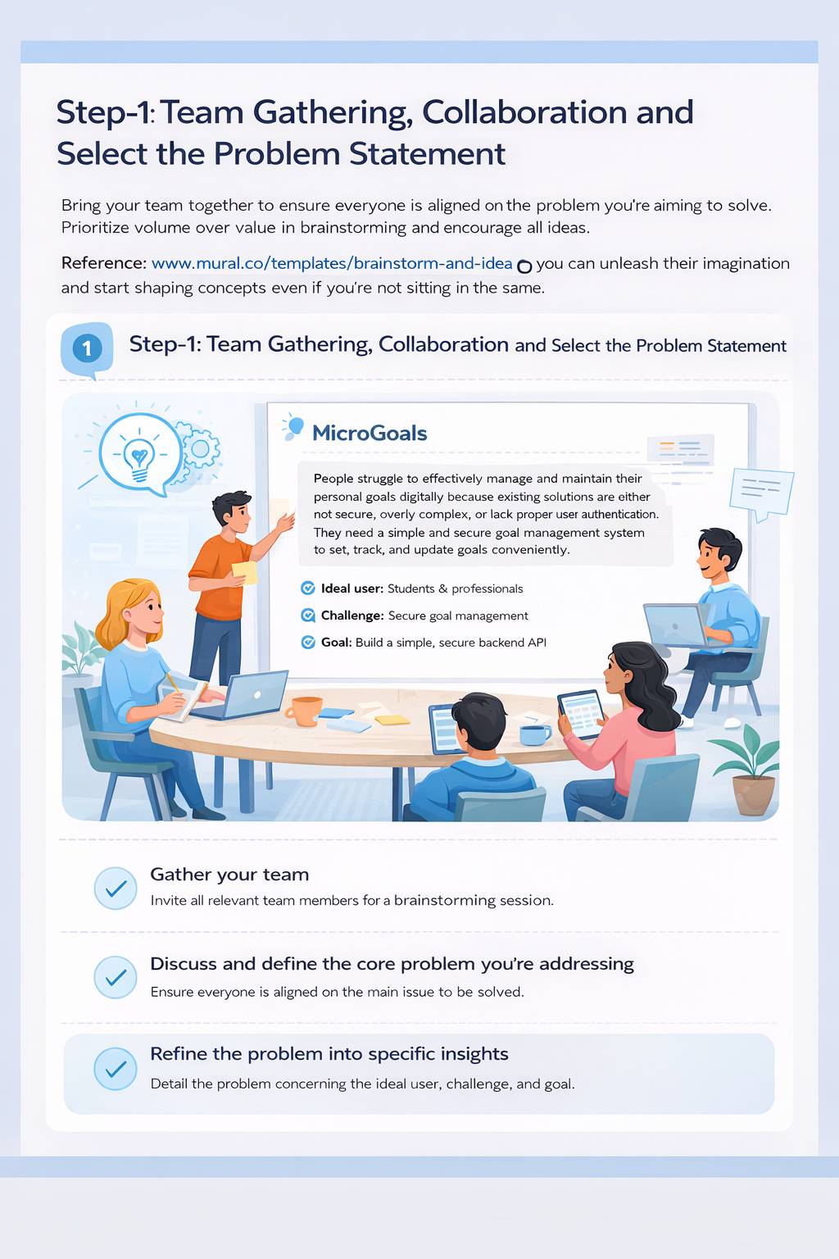

Step-2: Brainstorm, Idea Listing and Grouping:-
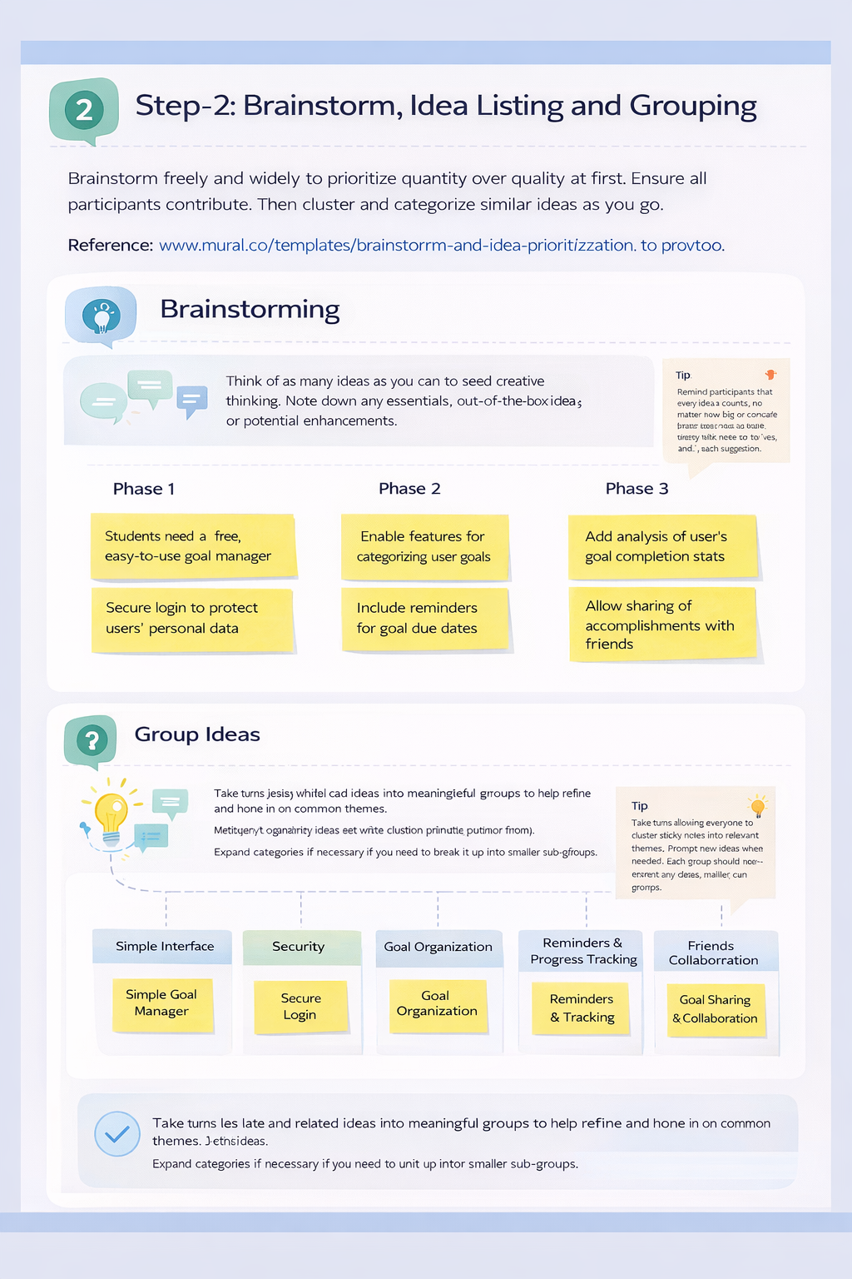
Step-3: Idea Prioritization:-
